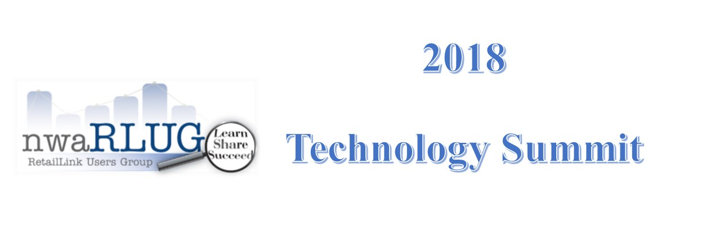

Thursday, January 18, 2018 2:00p.m. – 5:00 p.m.
Shewmaker Center, Walmart Auditorium
1000 SE Eagle Way, Bentonville, AR 72712

nwaRLUG Technology Summit 2:00pm – 5:00pm

While nwaRLUG does not officially endorse or recommend any 3rd party companies or 3rd party software. We are continually contacted and have received requests to provide information about our local 3rd Party Companies. Therefore, we have brought back the summit giving our suppliers and nwaRLUG members an opportunity to hear from a few of the data management and/or service providers.

Exhibitors will be available for attendees to visit with and obtain additional information from 2:00 p.m. - 5:00 p.m.:

Harvest Revenue Group

CHEP

WhyteSpyder

Shiloh

Atlas

Transactional Insights

Crossmark

CaseStack

Interactive Edge

CRA

RSI (Retail Solutions)
. . . and others

Silent Auction & Goodie Bags 2:00pm – 5:00 pm
Each year nwaRLUG awards scholarships to help support NWACC students enrolled in the Certified Retail Analyst Program. To raise money for the scholarship, a silent auction is usually held in December; however, we will be hosting the silent auction in conjunction with the Summit.
The first 400 attendees will receive a goodie bag!!!
2018 Meeting Dates… www.nwaRLUG.org
Exhibitors& Donations for the Auction & Goodie Bag Donations are still being accepted!

For information regarding Exhibitor space please contact:
Chris Roberts Email: CRoberts@FiveHour.com
Dan Batson Email: President@nwaRLUG.org
Rhonda Evans: Secretary@nwaRLUG.org

To Donate for the Auction please contact:
Sherrie Whilite
Email: sherrie.wilhite@uscotton.com
Phone: (479) 251-1002
or
Eileen Wilkerson
Email: Ewilkerson@bigtimeproducts.net
Phone: (479) 308-8364
or
Wendy Nickel
Email: Wendi.Nickel@flocorp.com
Phone: (479) 273-1672

For Goodie Bag Donations please contact:
Chris Roberts
Email: CRoberts@FiveHour.com
Phone: (479) 799-0222

